Dromin National School
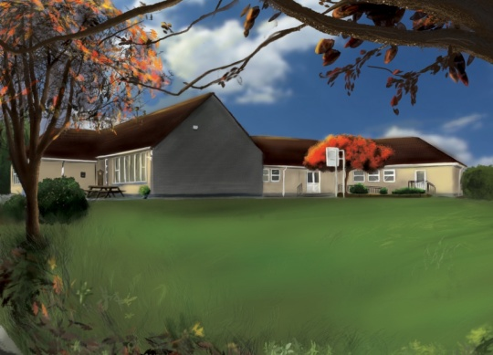

5th Class Booklist 2022-2023

1. Booklist:
Items in black to be purchased by parents/guardians.
Items in red are part of book rental and will be distributed in September.

Subject | Book | Publisher | Buy | Rent
English | Above the Clouds  Word Wizard 5th Class  Fallons Spelling Book  English Dictionary | Fallons  Gill & Macmillan  Fallons  Collins | €23.75  € 9.95  € 6.15  € 5.99 | €7.00  €3.00
Gaeilge | Caint is Comhrá 5 | Fallons | €21.95 | €7.00
Maths | Busy at Maths 5th Class  Table Book | Fallons  Fallons | €22.50  € 2.45 | €7.00
History | Small World-History 5th Class | Fallons | €14.30 | €3.00
Geography & Science | Small World-Geography & Science 5th Class  Primary Atlas | Fallons  Collins | €14.30  € 9.59 | €3.00
Religion | Grow in Love 5th Class | Veritas | €16.75 | €4.00
Prices may vary with different retailers.

2. Stationary: (Items to be purchased by parents).
2 x Maths copies (88 page)
10 x Copies (88 page)
1 x B4 red and blue line copy
2 x ½ blank copies
1 x Homework Diary
All stationary must be labelled.

3. Cost of Fees:
BOOK RENTAL €34.00
Art & Craft Materials/Photocopying/Ink €36.00
I.C.T.: Text-A-Parent/Aladdin € 4.00
Insurance: 24-hour cover € 6.00
€80.00
Total Fees Due:

4. Payment: (Child’s Name & Class referenced on all payments).
This amount of €80.00 should be paid by Electronic Transfer (ET) to the following account:
BIC: BOFIIE2D IBAN: IE61 BOFI 9034 2924 9056 72
** When paying by ET, please remember to put your child’s name as payment reference so the monies can be allocated to their profile. Alternatively, monies can be paid by cash or cheque (payable to Dromin N.S.) to the class teacher before Friday the 24^{h} June, 2022**.

