Dromin National School
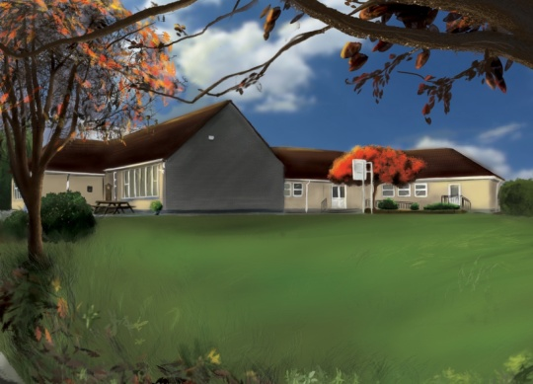

6th Class Booklist 2022-2023

1. Booklist:
Items in black to be purchased by parents/guardians.
Items in red are part of book rental and will be distributed in September.

Subject | Book | Publisher | Buy | Rent
English | Flying High  Word Wizard 5th Class  Fallons Spelling Book  English School Dictionary | Fallons  Gill & Macmillan  Fallons  Collins | €23.75  € 9.95  € 6.15  € 5.99 | €7.00  €3.00
Gaeilge | Caint is Comhrá 5 | Fallons | €21.95 | €7.00
Maths | Busy at Maths 6th Class  Table Book | Folens  Fallons | €22.50  € 2.45 | €7.00
History | Small World-History 5th Class | Fallons | €14.30 | €3.00
Geography & Science | Small World-Geography & History 5th Class  Primary Atlas | Fallons  Collins | €14.30  € 9.59 | €3.00
Religion | Grow in Love 5th Class | Veritas | €16.75 | €4.00
Prices may vary with different retailers.
2. Stationary: (Items to be purchased by parents).
2 x Maths copies (88 page)
10 x Copies (88 page)
1 x B4 red and blue line copy
2 x ½ Blank Copies
1 x Homework Diary
All stationary must be labelled.

3. Cost of Fees
BOOK RENTAL €34.00
Art & Craft Materials/Photocopying/Ink €36.00
I.C.T.: Text-A-Parent/Aladdin € 4.00
Insurance: 24-hour cover € 6.00
€80.00
TOTAL FEES DUE

4. Payment: (Child’s Name & Class referenced on all payments).
This amount of €80.00 should be paid by Electronic Transfer (ET) to the following account:
BIC: BOFIIE2D IBAN: IE61 BOFI 9034 2924 9056 72
*** When paying by ET, please remember to put your child’s name as payment reference so the monies can be allocated to their profile. ***
Alternatively, monies can be paid by cash or cheque (payable to Dromin N.S.) to the class teacher before Friday the 24th June, 2022.

