Dromin National School
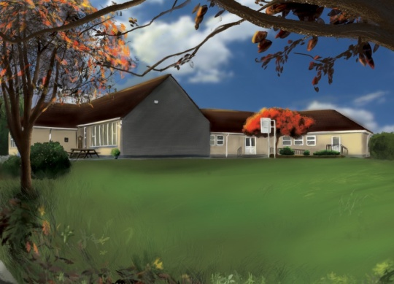

4th Class Booklist 2022-2023

1. Booklist:
Items in black to be purchased by parents/guardians.
Items in red are part of book rental and will be distributed in September.

Subject | Book | Publisher | Buy | Rent
English | Word Wizard 4  Spelling Book- (use same book as last year).  English Dictionary- (use same as last year).  Homework Diary  Lift Off! | Gill & Macmillan  Fallons  Fallons  Fallons  Fallons | € 9.95  € -  € -  € 3.50  €22.65 | €3.00  €7.00
Gaeilge | Caint is Comhrá 3  Am don Léamh 4 | Fallons  Folens | €20.95  € 7.60 | €3.00
Maths | Table Book - (use same book as last year).  Busy at Maths 4 | Fallons  Fallons | € -  €22.95 | €7.00
History | Small World History 4th Class | Fallons | €13.75 | €3.00
Geography & Science | Primary Atlas  Small World-Geography & Science 4th Class | Collins  Fallons | € 9.59  €13.75 | €3.00
Religion | Grow in Love 4th Class | Veritas | €14.50 | €3.00
Prices may vary with different retailers.
2. Stationary: (All copies, pencils & crayons will be purchased by the class teacher in September).
Stationary & books must be clearly labelled.
3. Cost of Fees
BOOK RENTAL €29.00
Art & Craft Materials/Photocopying/Ink €33.00
Copies, Pencils, Crayons €15.00
Writer’s Workshop Portfolio € 3.00
I.C.T.: Text-A-Parent/Aladdin € 4.00
Insurance: 24-hour cover € 6.00
€90.00
Total cost of Fees:

4. Payment: (Child’s Name & Class referenced on all payments).
This amount of €90.00 should be paid by Electronic Transfer (ET) to the following account:
BIC: BOFIIE2D IBAN: IE61 BOFI 9034 2924 9056 72
** When paying by ET, please remember to put your child’s name as payment reference so the monies can be allocated to their profile. Alternatively, monies can be paid by cash or cheque (payable to Dromin N.S.) to the class teacher before Friday the 24th June, 2022**.

