Dromin National School
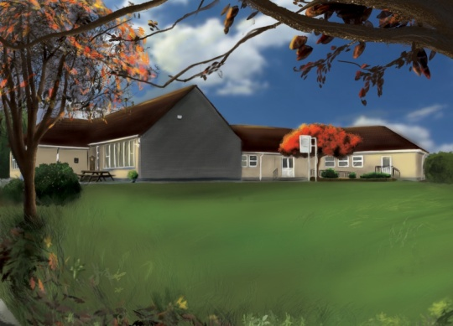

Senior Infants Booklist 2022-2023

1. Booklist:
All Items in black to be purchased by parents/guardians.
All Items in red are part of book rental and will be distributed in September.

Subject | Book | Publisher | Buy | Rent
English | Just Handwriting SI+ Practice Copy Pre-cursive Handwriting  Starlight Senior Infants Skills Book (Blue)  Sounds Make Words SI  Sounds in Action (Red) SI  Spell Bound (Purple) SI  Starlight Core Reader 1-SI  Starlight Core Reader 2-SI  Starlight Core Reader 3-SI  Starlight Core Reader 4-SI | Educate.ie  Folens  Folens  Folens  Folens  Folens  Folens  Folens  Folens | € 4.95  € 9.65  € 7.90  € 7.90  € 7.85  € 6.40  € 6.40  € 6.40  € 6.40 | €2.00  €2.00  €2.00  €2.00
Maths | Busy at Maths-Senior Infants Book  Figure it Out-Senior Infants  Sum Detective-Senior Infants | Fallons  Fallons  Folens | € 10.80  € 7.00  € 7.90
Gaeilge | Abair Liom A – 2nd Edition | Folens | € 12.15
SESE | Window on the World Activity Book A | Edco | € 9.70
Religion | Grow in Love-Senior Infants | Veritas | € 10.50
Prices may vary with different retailers.
2. Stationary: (All copies, pencils & crayons will be purchased by the class teacher in September).
Stationary & books must be clearly labelled.
3. Cost of Fees:
BOOK RENTAL € 8.00
Art & Craft Materials/Photocopying/Ink €35.00
Copies, Pencils, Crayons €17.00
I.C.T. Text-A-Parent/Aladdin € 4.00
Insurance: 24-hour cover € 6.00
€70.00
Total Fees Due:

4. Payment: (Child’s Name & Class referenced on all payments).
This amount of €70.00 should be paid by Electronic Transfer (ET) to the following account:
BIC: BOFIIE2D IBAN: IE61 BOFI 9034 2924 9056 72
** When paying by ET, please remember to put your child’s name as payment reference so the monies can be allocated to their profile. Alternatively, monies can be paid by cash or cheque (payable to Dromin N.S.) to the class teacher before Friday the 24th June, 2022**.

